Mood Portraits
Photograph a person or yourself in such a way that captures one of the listed moods. Capture 16 different moods. 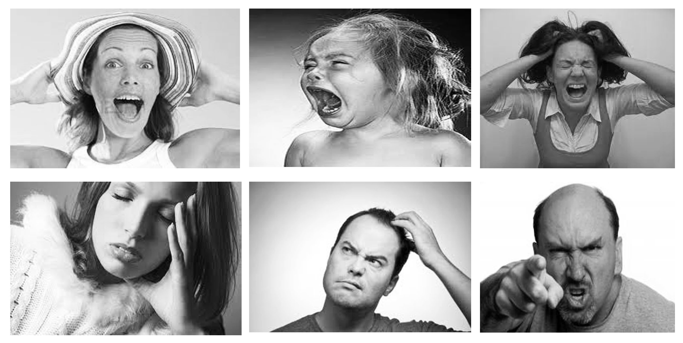
Accepted Accomplished Aggravated Alone Amused Angry Annoyed Anxious Apathetic Ashamed Awake Bewildered Bittersweet Blah Blank Blissful Bored Bouncy Calm Cheerful Chipper Cold Complacent Confused Content Cranky Crappy Crazy Crushed Curious Cynical Dark Depressed Determined Devious Dirty Disappointed Discontent Ditzy Dorky Drained Ecstatic Energetic Enraged Enthralled Envious Exanimate Excited Exhausted Flirty Frustrated Full Geeky Giddy Giggly Gloomy Good Grateful Groggy Grumpy Guilty Happy Hopeful Hot Hungry Hyper Impressed Indescribable Indifferent Infuriated Irate Irritated Jealous Jubilant Lazy Lethargic Listless Lonely Loved Mad Melancholy Mellow Mischievous Moody Morose Naughty Nerdy Numb Okay Optimistic Peaceful Pessimistic Pissed off Pleased Predatory Recumbent Refreshed Rejected Rejuvenated Relaxed Relieved Restless Rushed Sad Satisfied Shocked Sick Silly Sleepy Smart Stressed Surprised Sympathetic Thankful Touched Uncomfortable Weird
Assignment
Create a series of 16 different moods. The photos all must be the monochromatic (black and white) and be evenly spaced out on the grid. Try to have all different people or the same individual for all the shots. Remember to shoot against a solid/plain backdrop and have even lighting on their face.

